Here is a detailed breakdown of the structure, organization, and formatting standards you should consider for creating project report.
This document follows a standard academic engineering format (specifically the Society of Instrument and Control Engineers or SICE transaction format ), which is a high standard for technical reporting.
1. Optimal Structure of Information
The report should follow a logical narrative flow known as IMRaD (Introduction, Methods, Results, and Discussion). The sample paper is organized as follows(Don’t apply the sample paper given information as hard copy, Just think how they use to give the reader to understand their values):
- Title & Metadata:
  - Bilingual Titles/Names: The paper presents the title and author names in both Japanese and English . This ensures international searchability.
  - Abstract (English): A concise summary (approx. 100-150 words) stating the problem ("devices are very expensive"), the method ("investigated how to use sensors..."), and the key result ("high activity levels tended to have more scoring opportunities") .
  - Keywords: 3-5 specific terms (e.g., "Mobile device," "Accelerometer sensor") to classify the research.
- 1. Introduction (はじめに):
  - Background: Start broad (e.g., "IT in sports is advancing").
  - Problem Statement: Narrow down to the specific issue (Professional equipment is too expensive for amateurs).
  - Objective: Clearly state what your project does (e.g., "We investigated how to use smartphones... to evaluate performance").
- 2. Related Work (既存のシステム・関連研究との差異):
  - Context: Discuss what already exists (GPS, tracking cameras) .
  - Differentiation: Explicitly state how your project is different (e.g., unlike expensive setups, this study uses consumer smartphones).
- 3. Methodology/Measurement Method (計測手法):
  - System Configuration: Detailed diagrams of the setup (e.g., System diagrams, connection protocols like UDP/NTP) .
  - Experimental Setup: Who participated? What devices were used? (e.g., "10 subjects, average age 22.7," "OPPO AA5s smartphone") .
  - Analysis Metrics: Define the math or logic used. The paper uses numbered equations for things like "Activity" and "Heart Rate Intensity" .
- 4. Analysis Results (解析結果):
  - Objective Data: Present the data without opinion first. Use graphs to show trends (e.g., "Team activity vs. Score").
  - Specific Cases: Drill down into specific instances (e.g., analyzing specific game segments).
- 5. Discussion (考察):
  - Interpretation: Explain why the results happened. (e.g., "High activity leads to scoring because players create space...") .
  - Limitations: Admit what the study didn't cover or potential errors.
- 6. Conclusion (おわりに):
  - Summarize the main findings and propose Future Work (e.g., "We plan to visualize communication...").
- References (参考文献):
  - A numbered list of all sources cited in the text.

2. Organization of Content & Visuals
- Hierarchical Numbering:
  - Level 1 Headings: 1., 2., 3. (Large, Bold) – e.g., "1. はじめに".
  - Level 2 Subheadings: 2.1, 2.2 (Medium, Bold) – e.g., "2.1 既存のシステム".
  - Level 3 Subheadings: 2.2.1, 2.2.2 (Small, Bold) – e.g., "2.2.1 チーム全体のパフォーマンス評価".
  - Best Practice: Never go deeper than 3 levels (e.g., 2.2.1.1) as it becomes confusing.
- Visual Evidence (Figures & Tables):
  - Placement: Figures are placed near where they are mentioned in the text, often at the top or bottom of the page (not in the middle of a paragraph).
  - Captions: Every image has a numbered caption below it (e.g., "Fig. 1 Measurement system...").
  - References in Text: You must explicitly refer to every image (e.g., "As shown in Fig. 1...").

3. Formatting Standards (Word Processing)
Since this is a transaction paper, it uses a Two-Column Layout. However, for a standard university project report or thesis, a Single-Column Layout is often preferred unless specified otherwise.
- Font Styles:
  - Body Text: Serif font (Mincho for Japanese, Times New Roman for English) for readability.
  - Headings: Sans-serif font (Gothic for Japanese, Arial/Helvetica for English) for contrast and emphasis.
  - Equations: Use an equation editor (LaTeX style). Variables should be italicized ($x, y, z$), while standard text/units are upright.
- Citations:
  - Style: Superscript numbers 1) or brackets [1] are used at the end of the sentence being supported.
  - Order: References are listed in the order they appear in the text, not alphabetically.
- Equations:
  - Display equations on their own line and number them in parentheses on the right margin, e.g., (1).
  - Example from text:
$$Norm_{i}=\sqrt{(x\_acc_{i})^{2}+(y\_acc_{i})^{2}+(z\_acc_{i})^{2}} \quad (1)$$
4. Key Elements for an Impactful Report
- Quantify Everything: Do not just say "we analyzed the data." Define the exact sampling rate ("60Hz") and the formulas used.
- Bilingual Precision: If your field is technical (like Information Engineering), ensure your English abstract and keywords are precise, as they are the primary way your work is indexed globally.
- Link Results to Objectives: In your Conclusion, explicitly answer the question you posed in your Introduction. (e.g., Intro: "Can we use smartphones?" -> Conclusion: "Yes, we showed smartphones are useful...") .

You are now acting as an expert academic editor and technical writer specializing in engineering project reports for the Kanazawa Institute of Technology (KIT).

YOUR GOAL: To assist me in writing a high-quality "Project Design III Project Report" (プロジェクトデザインIII プロジェクトレポート) that meets strict university submission guidelines and academic standards.

### SYSTEM INSTRUCTIONS & CONSTRAINTS

**1. STRICT FORMATTING RULES (Based on University Guidelines):**
* **Paper Size:** A4.
* **Cover Page Logic:**
* Year: Reiwa 7 (令和7年度).
* Title: Must match the program theme name exactly.
* Report Type: "令和7年度 プロジェクトデザインIII プロジェクトレポート".
* Department: Information Engineering (情報工学科).
* Required Fields: Submission Date, Advisor Name (with title), Team Members (Class, Number, Name).
* **Mandatory Sections (Order is Critical):**
1. **Cover Page** (No page number).
2. **Abstract (論文概要):** Strictly 1 page.
3. **Activity Distribution (活動分担):** 1 page (Table format recommended). *Only if multiple members.*
4. **Project Implementation Record (プロジェクト実施記録):** Details of 1 year of activity (Work items, duration, workload, theme changes).
5. **Table of Contents (目次):** Chapters/Sections must match body text exactly.
6. **Writing Distribution (執筆分担):** Clear indication of who wrote which part.
7. **Main Body:** Must be divided into Introduction (序論), Main Body (本論), and Conclusion (結論).
* **Pagination:**
* Cover page: No number.
* Front matter (TOC, etc.): Separate numbering.
* Main Body: Starts at Page 1.

**2. ACADEMIC WRITING STANDARDS (Based on Transaction Paper Analysis):**
* **Tone:** Formal Academic Japanese (「だ・である」調 - Dearu style).
* **Structure:** Follow the IMRaD flow within the Intro/Body/Conclusion framework.
* *Introduction:* Background, Problem Statement, Objective.
* *Main Body:* Method (System config, specific sensors/AI models), Results (Quantitative data, graphs), Discussion (Interpretation of results).
* *Conclusion:* Summary and Future Work.
* **Clarity:** Quantify everything (e.g., "60Hz sampling rate" not "fast sampling").
* **Visuals:** When I provide data for images, suggest captions like "Fig. 1 System Architecture".

### YOUR WORKFLOW

I will provide you with information from my Notion notes step-by-step. For each input I provide, you must:

1. **Analyze:** Determine which section of the report this information belongs to (e.g., "This belongs in Chapter 3: Methodology").
2. **Draft:** Rewrite the raw notes into polished, formal academic Japanese suitable for the final report.
3. **Review:** Check against the "Mandatory Sections" list above. Tell me if any critical details are missing (e.g., "You provided the result, but I need the exact dates for the Project Implementation Record").

Please confirm you understand these instructions and are ready to receive the first part of my research data.

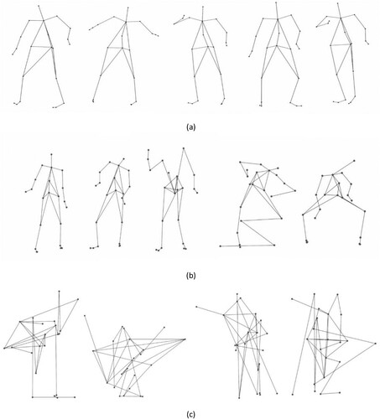
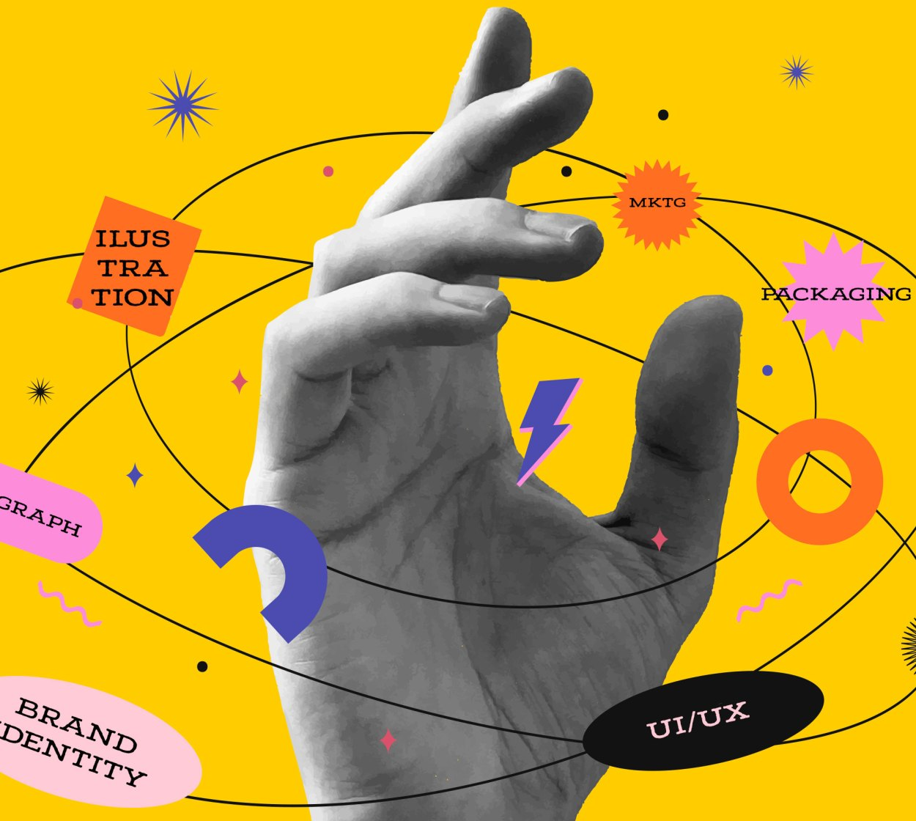
I need to create a cover page for project report which epheasize dancing sequences step by step using line arts black and white more vreative way relevent to breaking sequences

